

**A report on**

**“**SLEEP MONITORING SYSTEM**”**

**Submitted in partial fulfilment for the award of the degree of**

**BACHELOR OF TECHNOLOGY**

**IN**

**COMPUTER ENGINEERING**

**(SOFTWARE ENGINEERING)**

**Submitted by**

**SACHIN SINGH**

**(20BTRCS170)**

**AAYUSHMA THAPA**

**(20BTRSE072)**

**MANISH YADAV**

**(20BTRSE037)**

**PRIYANKA KUMARI**

**(20BTRCO072)**

**PREETI KURMI**

**(20BTRCO071)**

**Under the guidance of Prof. Santhosh S**

**Faculty of Engineering & Technology**

**Jain (Deemed-To-Be University) Department of Computer Science and Engineering**

Jain Global Campus, Kanakapura Taluk - 562112 Ramanagara District, Karnataka, India

2023-2024

**Department of Computer Science and Engineering**

Jain Global Campus, Kanakapura Taluk - 562112 Ramanagara District, Karnataka, India

**CERTIFICATE**

This is to certify that the project work titled **“SLEEP MONITORING SYSTEM”** is carried out by **Sachin Singh (20BTRCS170), Manish Yadav (20BTRSE037), Aayushma Thapa (20BTRSE072)** a Bonafede students of Bachelor of Technology in **Computer Engineering Engineering (Software Engineering)** and **Preeti kurmi (20BTRCO71), Priyanka Kumari (20BTRCO072)** a Bonafede students of Bachelor of Technology in **Computer Science & Engineering (Internet Of Things)** at the Faculty of Engineering & Technology, Jain (Deemed-to-be University), Bangalore in partial fulfilment for the award of degree, Bachelor of Technology in Computer Engineering (Software Engineering) during the Academic year **2023-2024**.

|  |  |  |
| --- | --- | --- |
| **Prof. Santhosh S Guide**  Dept. of CE-SE,  Faculty of Engineering & Technology,  Jain (Deemed-to-be University)  Date: | **Prof. Santosh S**  ProgramHead, Dept. of CE-SE,  Faculty of Engineering & Technology,  Jain (Deemed-to-be University)  Date: | **Dr. Geetha G**  Director,  School of Computer Science & Engineering  Jain (Deemed- to-be University)  Date: |

**Name of the Examiner Signature of Examiner**

1.

2.

# DECLARATION

We**, Sachin Singh (20BTRCS170), , Manish Yadav (20BTRSE037), Aayushma Thapa (20BTRSE072)** are students of seventh semester **B. Tech** in **Computer Engineering** (**Software Engineering)** and **Preeti kurmi (20BTRCO71) Priyanka Kumari (20BTRCO072),** are students of seventh semester **B.Tech in Computer Science & Engineering (Internet of Things),** at Faculty of Engineering and Technology, **Jain (Deemed- To-Be) University,** hereby declare that the project centric learning work titled **“SLEEP MONITORING SYSTEM”** has been carried out by us and submitted in partial fulfilment for the award of degree in **Bachelor of Technology** during the academic year **2023-2024.** Further, the matter presented in the project has not been submitted previously by anybody for the award of any degree or any diploma to any other University, to the best of our knowledge and faith.

|  |  |
| --- | --- |
| Sachin Singh  (20BTRCS170) | Signature |
| Manish Yadav  (20BTRSE037) | Signature |
| Aayushma Thapa  (20BTRSE072) | Signature |
| Preeti Kurmi  (20BTRCO071) | Signature |
| Priyanka Kumari  (20BTRCO072) | Signature |

Place: Bangalore Date:

# ACKNOWLEDGEMENT

*It is a great pleasure for us to acknowledge the assistance and support of a large number of individuals who have been responsible for the successful completion of this project work.*

*First, we take this opportunity to express our sincere gratitude to* ***Faculty of Engineering and Technology, Jain (Deemed-to-be) University,*** *for providing us with a great opportunity to pursue our Bachelor’s Degree in this institution.*

*In particular we would like to thank* ***Dr. Geetha G, Director, School of Computer Science and Engineering, Jain (Deemed-to-be University),*** *for his constant encouragement and expert advice.*

*It is a matter of immense pleasure to express our sincere thanks to* ***Mr. Santosh S, Program Head, Department of Computer Engineering (Software Engineeting), Jain (Deemed-to-be University),*** *for providing right academic guidance that made our task possible.*

*We would like to thank our internal guide* ***Mr. Santhosh S, Department of Computer Engineering (Software Engineering), Jain (Deemed-to-be University),*** *for sparing her valuable time to extend help in every step of our project work, which paved the way for smooth progress and fruitful culmination of the project.*

*We would like to thank our PCL coordinator* ***Dr. Rajinikanta Mohanty*** *and all the staff members of Computer Engineering (Software Engineering) for their support.*

*We are also grateful to our family and friends who provided us with every requirement throughout the course.*

*We would like to thank one and all who directly or indirectly helped us in completing the Project work successfully.*

*Signature of Students*

1. *Sachin Singh (20BTRCS170)*
2. *Manish Yadav (20BTRSE037)*
3. *Aayushma Thapa (20BTRSE072)*
4. *Priyanka Kumari (20BTRCO072)*
5. *Preeti Kurmi (20BTRCO071)*

**TABLE OF CONTENTS**

CERTIFICATE Error! Bookmark not defined.

DECLARATION Error! Bookmark not defined.

ACKNOWLEDGEMENT 4

ABSTRACT 8

CHAPTER 1 9

**INTRODUCTION 9**

1.1. Overview 10

1.2. Problem Definition 11

1.3. Objective(s) 11

1.4. Methodology 12

1.5. Hardware and Software used 13

CHAPTER 2 19

**LITERATURE SURVEY 19**

2.1. Related Work 26

2.2. Existing Work 27

2.3. Problems in Existing system 29

2.4. Market Survey 29

2.5. Proposed System 33

CHAPTER 3 35

**SYSTEM DESIGN 35**

1.1. System Architecture 35

1.2. Use Case Diagram 39

1.3. Class Diagram 40

1.4. Activity Diagram 41

1.5. Sequence Diagram 42

CHAPTER 4 44

**TOOLS DESCRIPTION 44**

4.1. Hardware Requirements: Description 44

4.2. Software Requirements: Description 44

CHAPTER 5 45

**IMPLEMENTATION 45**

5.1. Description 45

5.2. Code Snippets of Sleep Monitoring System 45

CHAPTER 6 52

**CONCLUSION 52**

REFERENCES 53

# ABSTRACT

Getting quality sleep is important for every person to get better physical health. Irregular sleep patterns may indicate the illness resulting in chronic depression, which makes the evaluation of the sleep cycle mandatory for a healthy body and mind. In the arena of globalization, along with the increased facilities, various other challenges have been probed to provide the quality health care facilities with the use of economical instruments and technology. The development of the Internet of Things (IoT) technology purports the preambles to build a consistent and cost-effective system to monitor the sleep quality of patients. Several other systems are available for this purpose; however, such systems are very costly and difficult to implement. To overcome the issue, this study suggests an inventive system to monitor and analyze the sleep patterns using ambient parameters. The proposed system is effective enough that it can proficiently monitor patient’s sleep using Commercial off the Shelf (COS) sensors as well as predicts the results using the intelligent capability of the random forest model. The patient’s bio status including physical movement of the body, heartbeat, SPO2 level (oxygen saturation in the blood for the proper functioning of the body), and snoring patterns could be measured through this system, in which recorded data is transmitted to the computer system in a real-time environment. This system consists of two parts. One part consists of analyzing the behavior of data using the intelligent technique of the random forest model and decision rules in a real-time environment. This real-time analysis notifies the caretaker about the situation of the patient. In the second part, batch data processing is performed which allows the detailed analysis of data using statistical methods to produce the overall condition of the patient in a specified interval of time. Through the proposed system, we can easily measure the sleep patterns of patients and provide them with better treatment by using this simple and cost-effective system. The patient’s sleep data is used to test this method through the validation of manual results, which provides the minimum error rate. This study highlights the implementation of an intelligent and smart sleep quality monitoring system using IoT on a variant number of people with minimum expense rate.

# CHAPTER 1

## INTRODUCTION

Sleeping is the need of the human body for their survivals and allows the user to remain fresh. There are many benefits which user gets while having the sufficient sleep which includes sleep keep heart healthy, prevent cancer, reduces stress, reduces inflammation, makes you more alert, improves your memory, help you lose weight, makes you smarter. The sleep requirements vary slightly from person to person, most healthy adults need seven to nine hours of sleep per night to function at their best. Children and teens need even more. And despite the notion that our sleep needs decrease with age, older people still need at least seven hours of sleep. The sleeping hours of the user varies as per their age and as per their physical and mental health standards.

According to the American Academy of Sleep Medicine there are 81 official sleep disorders, presented in Seventy million people in the USA have a sleep disorder, the vast majority of which remain undiagnosed and untreated. It is estimated that sleep-related problems incur $15.9 billion to national healthcare budget. There is then great need for automatic non-intrusive methods for sleep disorder recognition that patients can use in their homes. This would not only help decrease healthcare costs but also increase the number of diagnosed patients.

Another reason why sleep disorder detection is important is the fact that it is related to other potentially more serious medical conditions. According to results of their study involving 1,506 participants (out of which 83 % reported some medical condition) show that sleep disorders are related to comorbidities rather than age. This is most likely because major comorbidities such as stroke, heart disease, osteoporosis, or arthritis impact the patients’ quality of sleep. Detection of sleep disorders could therefore be an indication of another important disorder.

In the past, some methods using Electroencephalograms (EEG) or Electromyograms (EMG) have been proposed for sleep disorder monitoring. However, these methods are very inconvenient for the patients due to the cumbersome wiring that is required for the bio signal acquisition. On the contrary to those methods here, we propose a non-invasive system that is able to analyze and recognize sleep patterns which can be further utilized to detect various types of sleep disorders. The device which we implement here is bracelet which senses the activities whether we are sleeping in a right posture or not it detects our daily sleeping routines. It will monitor the sleeping activity of a person and will provide feedback that will help person in improving quality of sleep.

## Overview

In this survey, we are going to develop one system which detect all sleep time body movement and also it detects the time period of our sleep. The main motivation of this survey is to the device which we are going to implement here is device which senses the activities whether we are sleeping in a right posture or not it detects our daily sleeping routines. It will monitor the sleeping activity of a person and will provide feedback that will help person in improving quality of sleep.

In this project, we will use a mobile application to perform and analyzes to measure the sleep quality of patients. of energy for processing data. Previous studies proposed the systems that are costly as well. These systems comprise of those components that are not commercially available in the market. The proposed sleep observing system consists of commercially available Smartwatch having sleep detection feature. This system monitors the ambient factors of patient and physical movement during sleep. The main purpose of this study is to propose a sleep observing system, which can be used for patients at homes or in hospitals cost-effectively and can-do monitoring in more than one day/night.

The proposed approach has the following key features.

|  |  |
| --- | --- |
| (i) | This approach uses smartwatch that contain three sensors: an accelerometer, a microphone, and a pulse oximeter |
| (ii) | This approach uses an intelligent random forest method to predict the sleeping quality of the person |
| (iii) | This approach is low cost as it uses very cheap and easily available sensors for monitoring sleep |
| (iv) | The proposed approach can be effectively used at home or in the hospital, to monitor the patient’s sleep patterns during sleep |
| (v) | The proposed system is intelligent enough that it works accurately with a minimum error rate |

This system contributes to medical science technology by helping people to enjoy better sleep. The main objective of this work is to offer a system that should be inexpensive as well as easy to use for patients with a better level of accuracy.

## Problem Definition

Inadequate sleep is a significant health issue that affects a large percentage of the population. Poor sleep can lead to a variety of physical and mental health problems, including obesity, diabetes, hypertension, depression, and anxiety. Many people struggle to understand their sleep patterns and make meaningful changes to improve their sleep. A sleep monitoring system using a smartwatch and machine learning can help people track their sleep and receive personalized recommendations for improvement.

The solution is to develop a sleep monitoring system that uses a smartwatch to collect data about the user's sleep, and machine learning algorithms to analyze the data and provide personalized insights and recommendations. The system will track various sleep metrics, such as sleep duration, sleep quality, and REM sleep, and use this data to generate a sleep score. The system will then analyze the sleep score and provide insights into the user's sleep patterns, such as when they are most likely to wake up, how often they wake up during the night, and how much deep and REM sleep they are getting. Based on this analysis, the system will provide personalized recommendations for improving the user's sleep, such as adjusting their sleep schedule, increasing physical activity, or reducing caffeine intake. The system will also allow users to track their progress over time and adjust their sleep goals and settings accordingly.

## Objective(s)

1. To assist the user in understanding individual sleep patterns with the objective of improving sleep and optimizing daytime performance or treating sleep problems such as sleep disorders.
2. To reduce the chances of Insomnia and to have a proper sleep.
3. To develop a mobile application to help sleeping disorder patients, insomnia patients by keeping track of their sleeping cycles and seek for emergency help with ease.
4. Here, after developing mobile application, we keep all the records of data in this application and help the patients to overcome from this problem.
5. To upgrade the monitoring system, it will detect the time of sleeping, posture of sleeping and our sleep quality.
6. This system is mainly applicable for the people who are suffering from stroke, heart disease, and so on which will impact their quality of sleep.
7. The system will monitor the sleeping activity of a person and will provide the feedback based on data analyzed by the mobile application using machine learning that will help person in improving quality of sleep.

## Methodology

Sleep Monitoring Device is a wearable smartwatch that is tied on the hand of a person at sleep time. During sleep physiological demands are reduced and temperature and blood pressure drop. In general, many of our physiological functions such as brain wave activity, breathing, and heart rate are quite variable when we are awake or during REM (Rapid Eye Movement) sleep, but are extremely regular when we are in non-REM (Non-Rapid Eye Movement) sleep. REM sleep is a kind of sleep that occurs at intervals during the night and is characterized by rapid eye movements, more dreaming and bodily movement, and faster pulse and breathing. Non-REM sleep is is a quiet sleep state of sleep that occurs regularly during a normal period of sleep with intervening periods of [REM sleep](https://www.merriam-webster.com/dictionary/REM%20sleep) and is characterized by [delta wave](https://www.merriam-webster.com/dictionary/delta%20wave) brain activity, little dreaming, and a reduced level of autonomic physiological activity.

| **Physiological Process** | [**NREM**](https://www.ncbi.nlm.nih.gov/books/n/nap11617/glossary/def-item/gl82/) | [**REM**](https://www.ncbi.nlm.nih.gov/books/n/nap11617/glossary/def-item/gl98/) |
| --- | --- | --- |
| Brain activity | Decreases from wakefulness | Increases in motor and sensory areas, while other areas are similar to [NREM](https://www.ncbi.nlm.nih.gov/books/n/nap11617/glossary/def-item/gl82/) |
| Heart rate | Slows from wakefulness | Increases and varies compared to [NREM](https://www.ncbi.nlm.nih.gov/books/n/nap11617/glossary/def-item/gl82/) |
| Blood pressure | Decreases from wakefulness | Increases (up to 30 percent) and varies from [NREM](https://www.ncbi.nlm.nih.gov/books/n/nap11617/glossary/def-item/gl82/) |
| Sympathetic nerve activity | Decreases from wakefulness | Increases significantly from wakefulness |
| Muscle tone | Similar to wakefulness | Absent |
| Blood flow to brain | Decreases from wakefulness | Increases from [NREM](https://www.ncbi.nlm.nih.gov/books/n/nap11617/glossary/def-item/gl82/), depending on brain region |
| Respiration | Decreases from wakefulness | Increases and varies from [NREM](https://www.ncbi.nlm.nih.gov/books/n/nap11617/glossary/def-item/gl82/), but may show brief stoppages; coughing suppressed |
| Airway resistance | Increases from wakefulness | Increases and varies from wakefulness |
| Body temperature | Is regulated at lower set point than wakefulness; shivering initiated at lower temperature than during wakefulness | Is not regulated; no shivering or sweating; temperature drifts toward that of the local environment |
| Sexual arousal | Occurs infrequently | Greater than [NREM](https://www.ncbi.nlm.nih.gov/books/n/nap11617/glossary/def-item/gl82/) |

So with the help of sleep monitoring device, we are going to measure different aspect of REM sleep.

## Hardware and Software used

Sleep monitoring devices uses market available smartwatches that contain different sensors such as optical heart rate sensor, accelerometer sensor, gyroscope, ambient light sensor and microcontroller. And for storing and analyzing the data received from the sensors, we use a mobile application where the data is going to be analyzed using a machine learning algorithm and a proper schedule for sleep. Whole system is divided into two parts:- Hardware part and Mobile application.

**Hardware**

In hardware, we use optical heart rate sensor, accelerometer sensor, gyroscope, ambient light sensor and microcontroller.

1. **Optical heart rate sensor**

An optical heart rate sensor measures pulse waves, which are changes in the volume of a blood vessel that occur when the heart pumps blood.

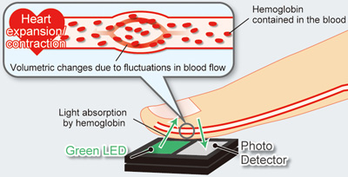

It is either integrated within a wrist-worn device, an arm band, or a chest patch, optical heart-rate monitors are capable of accurately measuring heart rate by assessing the arterial pulse of underlying skin vascular beds. Optical heart rate sensor is used for measuring pulse waves which change the volume of a blood vessel that occur when the heart pumps blood. Pulse waves are detected by measuring the change in volume using an optical sensor and green LED. It was found that heart rate sensors produce accurate readings irrespective of the age of the user. It have unique advantage such as high sensitivity, immunity to electromagnetic interference, small size ,light weight, flexibility and to provide multiplexed or distributed sensing.

1. **Accelerometer sensor**

An accelerometer sensor is a tool that measures the acceleration of any body or object in its instantaneous rest frame. Accelerometer sensors are ICs that measure acceleration, which is the change in speed (velocity) per unit time.

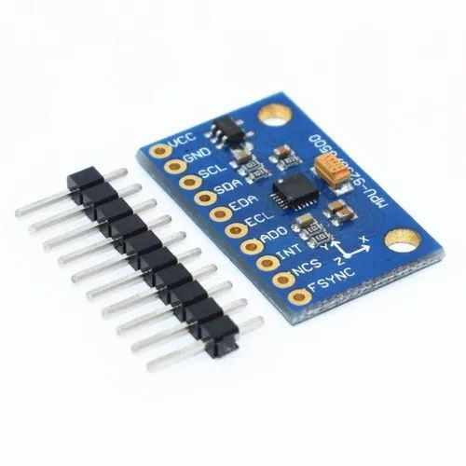

Accelerometer sensors are used in many ways, such as in many electronic devices, smartphones, and wearable devices, etc. Accelerometers can be used to measure vibration on cars, machines, buildings, process control systems and safety installations. They can also be used to measure seismic activity, inclination, machine vibration, dynamic distance and speed with or without the influence of gravity.

Accelerometer sensor are mostly used in sleeping devices. This sensor is used to measure how much movement patients makes during their sleep. Here we aim to develop and evaluate a heuristic algorithm for the detection of the sleep from raw data accelerometers and to compare sleep parameters either sleep diary records accessed in the daily life of a adults and older aged people.

1. **Gyroscope**

A gyroscope is a device that is used for measuring or maintaining orientation and angular velocity. It typically consists of a spinning wheel or rotor that is mounted on an axis and can rotate freely in any direction. The rotor maintains its orientation in space, which means that it will resist any changes in the direction of its spin axis. Gyroscopes are used in a wide range of applications, including navigation systems, aerospace engineering, robotics, and stabilization of cameras and drones. They are also used in everyday objects such as smartphones and gaming controllers to provide motion sensing capabilities.

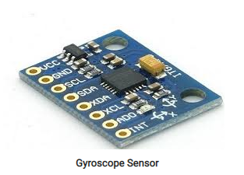

During sleep, the gyroscope can detect movements such as turning over or changing positions, as well as more subtle changes in orientation caused by breathing and heart rate. By analyzing these movements and changes over time, the smartwatch can provide data on the wearer's sleep duration, sleep stages, and quality of sleep. Gyroscope can track the wearer's movements and determine when they are in deep sleep, light sleep, or REM (rapid eye movement) sleep. It can also detect interruptions in sleep, such as when the wearer wakes up or experiences restless sleep.

1. **Ambient Light Sensor**

An ambient light sensor is a type of sensor commonly found in electronic devices such as smartphones, laptops, and smartwatches. It measures the amount of light in the environment and adjusts the device's display brightness accordingly. The ambient light sensor works by detecting the amount of light falling on a small photodiode or phototransistor. The sensor then sends a signal to the device's software, which adjusts the brightness of the display to a level appropriate for the ambient lighting conditions.

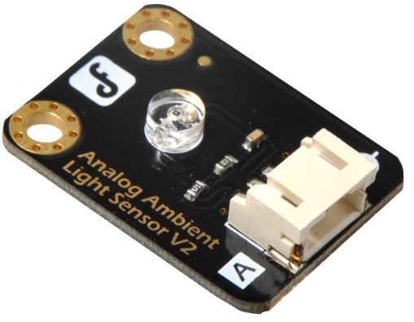

Ambient light sensors can also be used in sleep monitoring by detecting changes in the lighting conditions in a room. By measuring the amount of light in the environment, a sleep tracker or smartwatch can determine when the wearer has gone to bed and when they wake up. For example, when the wearer turns off the lights and goes to bed, the ambient light sensor can detect the drop in light levels and trigger the start of the sleep tracking. Similarly, when the wearer wakes up and turns on the lights, the sensor can detect the increase in light levels and trigger the end of the sleep tracking. In addition to tracking sleep duration, the ambient light sensor can also provide insights into the quality of sleep. For example, if the sensor detects changes in the light levels during the night, such as from a passing car or streetlight, it may indicate that the wearer had a restless night and was disturbed by external factors.

1. **Microcontroller**

The microcontroller used in a smartwatch can vary depending on the specific brand and model of the watch. Some popular microcontrollers used in smartwatches include the ARM Cortex-M series and the STMicroelectronics STM32 series. For example, the Apple Watch Series 7 uses the Apple S7 SiP (System in Package), which includes a custom-designed Apple S7 processor based on the ARM Cortex-M architecture. Similarly, the Samsung Galaxy Watch 4 uses the Exynos W920, a processor developed by Samsung Electronics specifically for wearables, which is also based on the ARM Cortex-M architecture. Other smartwatches may use different microcontrollers depending on their specific requirements and design considerations. Ultimately, the choice of microcontroller will depend on factors such as performance requirements, power consumption, and cost.

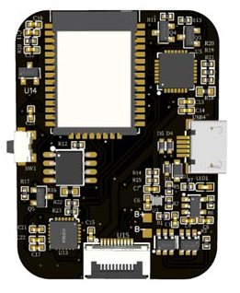

The microcontroller plays an important role in smartwatches that monitor sleep, as it is responsible for collecting and processing data from the various sensors used to track sleep. The microcontroller typically receives data from the accelerometer, heart rate monitor, gyroscope, and ambient light sensor, and then uses algorithms to analyze this data and determine when the wearer is asleep and what stage of sleep, they are in. The microcontroller can also store this data and communicate it to the user or to a smartphone app. In addition to sleep monitoring, the microcontroller in a smartwatch can also perform other functions such as displaying the time and other notifications, tracking physical activity, and monitoring vital signs such as heart rate and blood oxygen levels.

**Mobile Application**

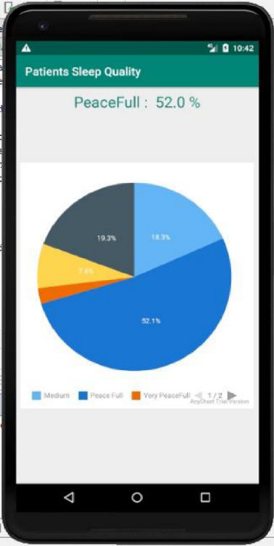A small android app is also developed which shows the status of a patient’s sleep quality. This app aids in effectively visualizing the sleep quality of the patient. Calculated results accessed by the app and shown in a pie chart will make it easy to know the overall sleep status of the patient. A screenshot of the app is shown in Figure:

In Figure, the patient’s sleep data is shown in a pie graph, as the graph depicts that patient’s sleep data is categorized into five different classes. Sleep quality for that patient is peaceful as shown in the graph. The peaceful sleep has been represented in blue color in this graph.

# CHAPTER 2

## LITERATURE SURVEY

The sleeping disorder refers to when the user is unable to sleep their normal hours which build up stress and have subsequent drastic effects on user’s health. Some of the drastic effects of the sleeping disorders are depression and in major case the sleeping disorder sometimes led to unconditional heart which makes it quite vital and important for the user to have subsequent hours of sleep. In the busy and hectic world, it’s quite normal to get stressed but the nap in between the work enables better mind freshness and subsequently provides enhanced work focus. Several inventions have been developed which allows the user to get themselves relaxed at the workplace.

In the paper “Sleep monitoring systems: Current status and future challenges” The authors draw attention to the shortcomings of current monitoring techniques like actigraphy and polysomnography in terms of accuracy and usefulness in daily life. The lack of uniformity among various sleep monitoring technologies can make it challenging to compare the findings of different studies. When it comes to privacy and data security, there are ethical issues with the gathering and use of sleep data. In order to address the difficulties associated with sleep monitoring, the paper suggests some potential solutions, such as the creation of new monitoring technologies, the standardization of measurement procedures, increased cooperation between experts in various fields, and more study to determine the connection between sleep and health. [1]

In “A Real-Time Sleep Monitoring System with a Smartphone”, to track sleep patterns and stages, the article suggests a real-time sleep monitoring system that makes use of a smartphone's sensors and machine learning algorithms. The system seeks to solve the drawbacks of current sleep monitoring technologies by offering a more practical and available remedy. The paper outlines the difficulties in creating a dependable and precise sleep monitoring system and outlines the strategy utilized to solve these difficulties. A small test group of participants used the suggested system, and the results indicated that it performed admirably in identifying sleep stages and metrics related to sleep quality. [2]

In “Internet of Things for Sleep Quality Monitoring System: A Survey”, This research does a literature review on the usage of the Internet of Things (IoT) for tracking sleep quality. The purpose of the study is to describe the current developments, problems, and potential future lines of inquiry in this field. The study covers a variety of topics related to IoT-based sleep quality monitoring, such as sensor technologies, data analytics, and privacy and security issues. The study aims to highlight the future research areas for IoT-based sleep monitoring and to offer insights into the opportunities and problems in the development of such systems. The combination of numerous sensors and data analytics methods was suggested by the authors as a way to increase the precision and efficiency of sleep monitoring systems. [3]

In the paper, “Development of a sleep monitoring system with wearable vital sensor for home use” the main purpose of the study is to create a wearable home sleep monitoring system. The lack of a practical and reliable sleep monitoring device that can be used at home to enhance sleep quality and identify sleep disorders is the primary issue raised in the study. The suggested system analyses the data to provide sleep quality assessment and sleep disorder detection. It does this by using a wearable sensor to measure vital signs like heart rate, respiration rate, and body movement. The study also analyses and suggests solutions for the problems associated with creating a wearable sleep monitoring system. [4]

The paper “Nonconstrained Sleep Monitoring System and Algorithms Using Air-Mattress with Balancing Tube Method” presents a non-invasive approach to monitor sleep patterns using an air-mattress with a balancing tube method. The system utilizes non-invasive sensors and advanced algorithms to collect and process data on various parameters such as heart rate, respiratory rate, body movements, and sleep stages. The system provides valuable insights into sleep quality and potential sleep disorders, making it a reliable and effective tool for sleep monitoring. The study conducted to evaluate the accuracy of the system shows high accuracy in detecting sleep stages compared to polysomnography (PSG), which is considered the gold standard for sleep monitoring.[5]

The paper “Development and Preliminary Validation of Heart Rate and Breathing Rate Detection Using a Passive, Ballistocardiography-Based Sleep Monitoring System” presents a passive, ballistocardiography-based sleep monitoring system that can detect heart rate and breathing rate during sleep. The system utilizes a pressure-sensitive mat placed under the mattress to detect ballistocardiographic (BCG) signals generated by the body's movements during sleep. The BCG signals are processed using advanced algorithms to detect heart rate and breathing rate, providing valuable information about the user's sleep patterns. The study conducted to validate the accuracy of the system shows that it has a high accuracy in detecting heart rate and breathing rate compared to polysomnography (PSG), making it a reliable and effective tool for sleep monitoring. [6]

The paper "Promises and Challenges in the Use of Consumer-Grade Devices for Sleep Monitoring" by Sirinthip Roomkham, David Lovell, Joseph Cheung, and Dimitri Perrin discusses the potential of consumer-grade devices such as smartphones, smartwatches, and fitness trackers for sleep monitoring. It presents an overview of the potential and challenges associated with the use of consumer-grade devices such as smartphones, smartwatches, and fitness trackers for sleep monitoring. The benefits include affordability, accessibility, and ease of use, while the challenges include accuracy and reliability of the data collected, privacy concerns, and lack of standardization. The paper also discusses the potential of machine learning algorithms to improve the accuracy of sleep monitoring using consumer-grade devices, highlighting the need for further research and development to improve the accuracy and reliability of these devices for clinical and personal use.[7]

The paper "Long-term Sleep Monitoring System and Long-term Sleep Parameters using Unconstrained Method" by Jaehyuk Shin, Youngjoon Chee, and Kwangsuk Park presents a long-term sleep monitoring system that can measure sleep parameters using an unconstrained method. It presents a long-term sleep monitoring system that uses an unconstrained method to measure various sleep parameters. The system utilizes a bed-based sensor system that can detect body movements, respiratory signals, and heart rate to calculate sleep stages, sleep efficiency, and other sleep parameters. The study shows that the system can accurately measure sleep parameters over long periods of time, making it a valuable tool for monitoring sleep disorders and evaluating the effectiveness of treatments. Overall, the system provides valuable insights into sleep patterns and potential sleep disorders while maintaining user comfort and ease of use.[8]

The paper "Validation of Sleep-Tracking Technology Compared with Polysomnography in Adolescents" by Massimiliano de Zambotti, Fiona C Baker, and Ian M Colrain presents a study that compares the accuracy of sleep-tracking technology with polysomnography in adolescents. This presents a study that compares the accuracy of a popular sleep-tracking device, Fitbit Charge HR, with polysomnography in adolescents. The study involved 25 participants and found that the Fitbit significantly underestimated total sleep time, sleep onset latency, and wake after sleep onset compared to polysomnography. The study highlights the importance of caution when using sleep-tracking technology for clinical or research purposes and suggests that more research is needed to improve the accuracy of such devices. Overall, the paper provides valuable insights into the limitations of sleep-tracking technology and the need for further research in this field. [9]

The paper "Sleep tracking in the real world: a qualitative study into barriers for improving sleep" by Zilu Liang and Bernd Ploderer presents a qualitative study on the barriers to improving sleep through the use of sleep-tracking technology. The paper presents a qualitative study on the barriers to improving sleep through the use of sleep-tracking technology. The study involved 12 participants who used a sleep-tracking device, and the results showed that accuracy and reliability of the device were significant concerns for the participants. Additionally, participants reported that the sleep data provided by the devices did not necessarily lead to changes in behavior or better sleep quality. The paper highlights the importance of considering user experience and motivation when designing sleep-tracking technology and the need for further research to improve the usability and effectiveness of such devices. [10]

The paper "Pyjamas, Polysomnography and Professional Athletes: The Role of Sleep Tracking Technology in Sport" by Driller et al. discusses the use of sleep tracking technology in professional athletes. The paper presents a case study of a professional rugby team that used sleep tracking devices to monitor their sleep and optimize their recovery. The study found that sleep tracking technology can provide valuable information for athletes and coaches to identify and address sleep-related issues, which can improve performance and reduce the risk of injury. The paper also highlights the challenges of using sleep tracking technology in a sports context, such as the need for reliable and accurate data and the importance of privacy and data protection. Overall, the paper provides insights into the potential benefits and challenges of using sleep tracking technology in professional sports. [11]

The paper "How Does Sleep Tracking Influence Your Life?" by Kuosmanen et al. investigates the impact of sleep tracking technology on individuals' behavior and perception of sleep. The study involved 20 participants who used a sleep tracking device and completed surveys and interviews. The results showed that sleep tracking technology had a positive impact on participants' awareness and understanding of their sleep patterns, leading to changes in sleep behavior and habits. However, the study also revealed concerns around data privacy, accuracy of the devices, and the potential for sleep tracking technology to create stress and anxiety around sleep. Overall, the paper highlights the potential benefits and drawbacks of sleep tracking technology, emphasizing the need for further research and design improvements to maximize the positive impact of such devices. [12]

The paper "The Design and Realization of Sleep-monitoring System Based on Body-movement Signals" by Wei et al. proposes a non-invasive sleep monitoring system that utilizes body movement signals to monitor sleep patterns. The system uses an accelerometer and a microcontroller to collect and analyze body movement data during sleep. The authors propose a sleep stage classification algorithm based on the Fast Fourier Transform (FFT) and linear discriminant analysis (LDA) techniques to analyze the movement data and classify sleep stages. The system was tested on five healthy volunteers, and the results showed promising accuracy in sleep stage classification. The proposed system provides a low-cost and non-invasive alternative to traditional sleep monitoring techniques, which could be useful for home-based sleep monitoring applications. [13]

The paper "High-Performance and Resource-Efficient IoT-based Sleep Monitoring System" presents a high-performance and resource-efficient sleep monitoring system based on the Internet of Things (IoT). The system uses an accelerometer and a microphone to collect body movement and snoring sounds, respectively, and transmits the data to a cloud server for analysis. The proposed system is designed to minimize power consumption and data transmission while ensuring accurate sleep monitoring. The experimental results demonstrate the effectiveness of the system in detecting sleep stages and sleep-related events with high accuracy, suggesting its potential for real-world applications in sleep monitoring and management. [14]

The paper "An unobtrusive sleep monitoring system for the human sleep behavior understanding" presents an unobtrusive sleep monitoring system based on a bed sensor for capturing sleep-related body movements, and a smartphone application for collecting self-reported sleep data. The proposed system aims to provide an accurate and complete understanding of sleep behavior, including sleep onset, duration, efficiency, and quality, and to identify sleep disorders. The system was evaluated through a pilot study involving 10 healthy subjects, showing that the system can provide valuable information for sleep monitoring and management, and has the potential to be used for sleep disorder diagnosis and treatment. [15]

The paper "A remote deep sleep monitoring system based on a single channel for in-home insomnia diagnosis" presents a remote sleep monitoring system that can diagnose insomnia in-home. The system is based on a single channel, and it uses an electroencephalogram (EEG) sensor to measure brain wave activity during sleep. The system also includes a wireless module that transmits the data to a remote server for analysis. The authors have tested the system on a small group of subjects and have achieved promising results. They conclude that the system could be a cost-effective and practical solution for in-home insomnia diagnosis. [16]

In “A survey on sleep assessment methods” by Vanessa Ibanez, Josep Silva and Omar Cauli, A literature review is presented that aims to summarize and compare current  
methods to evaluate sleep. By analyzing all the current sleep evaluation technique, they found that In order of accuracy, sleep detection methods may be arranged as follows:  
Questionnaire < Sleep diary < Contactless devices < Contact devices < Polysomnography  
A literature review suggests that current subjective methods present a sensitivity  
between 73% and 97.7%, while their specificity ranges in the interval 50%–96%.  
Objective methods such as actigraphy present a sensibility higher than 90%. However,  
their specificity is low compared to their sensitivity, being one of the limitations of such  
technology. [17]

In “Assistive technology to enable sleep function in patients with acquired brain injury: Issues and opportunities” by Anmol Biajar, Tatyana Mollayeva, Sandra Sokoloff and Angela Colantonio, different solution for sleeping disorders are proposed. They proposed solution like Continuous positive airway pressure (CPAP) therapy, Acupuncture, Cognitive behavioral therapy, Nasotracheal suction mechanical ventilation, Adaptive servo-ventilation, Light therapy, Positional therapy. These are some basic therapy that are for the brain injured persons having sleeping disorders. [18]

In “Non-invasive analysis of sleep patterns via multimodal sensor input” by Vangelis Metsis , Dimitrios Kosmopoulos and Vassilis Athitsos • Fillia Mak they analize sleep pattern of persons using Bed pressure mat sensor and Microsoft Kinect sensor. They collected data from 7 different individuals simulating their sleep habits. Each individual lied on the bed for a period of time and performed the actions that they would normally perform if they went to bed. The different actions performed during that period of time were recorded using 2 different sensors. The first one was a bed pressure mat that they put under the sheets, and the second one was a Microsoft Kinect sensor that they mounted on the ceiling. The recorded data were then manually annotated according to the various classes of interest, such body posture, motion occurrence, etc. The experimental results of this paper on real user datasets show that the task of analyzing sleep patterns with the intent to detect symptoms related to sleep disorders can be successfully achieved. [19]

In “Validation of a Consumer Sleep Wearable Device With Actigraphy and  
Polysomnography in Adolescents Across Sleep Opportunity Manipulations” by Xuan Kai Lee, Nicholas I.Y.N. Chee, Ju Lynn Ong, Teck Boon Teo, Elaine van Rijn, June C. Lo and Michael W.L. Chee, they compare the quality and consistency in sleep measurement of a consumer wearable device and a research-grade actigraph with polysomnography (PSG) in adolescents. Fifty-eight healthy adolescents (aged 15–19 years; 30 males) underwent overnight PSG while wearing both a Fitbit Alta HR and a Philips Respironics  
Actiwatch 2 (AW2) for 5 nights, with either 5 hours or 6.5 hours time in bed (TIB) and for 4 nights with 9 hours TIB. AW2 data were evaluated using two different wake  
and immobility thresholds. Discrepancies in estimated total sleep time (TST) and wake after sleep onset (WASO) between devices and PSG, as well as epochby-epoch agreements in sleep/wake classification, were assessed. As a results, Fitbit and AW2 under default settings similarly underestimated TST and overestimated WASO (TST: medium setting (M10) ≤ 38 minutes, Fitbit ≤ 47 minutes. Sensitivity for detecting sleep was ≥ 90% for both wearable devices and further improved to 95% by using the high threshold (H5) setting for the AW2  
(0.95). In addition, Fitbit inconsistently estimated stage N1 + N2 sleep depending on TIB, underestimated stage N3 sleep (21–46 min), but was comparable to PSG for rapid eye movement sleep. Fitbit sensitivity values for the detection of N1 + N2, N3 and rapid eye movement sleep were ≥ 0.68, ≥ 0.50, and ≥ 0.72, respectively. So it was concluded that A consumer-grade wearable device can measure sleep duration as well as a research actigraphy. However, sleep staging would benefit from further refinement before these methods can be reliably used for adolescents. [20]

U.S. Pat. No.10874350B2 for sleep monitoring system by inventor Ronald Stuart Benson, Toronto (CA) and Ryan Cameron Denomme, Kitchener (CA) discloses about a sleep systems having embedded sensors are described. In one aspect, a sleep system includes a mattress and one or more force sensors embedded within the mattress. The force sensors are positioned within the mattress to sense movement of an occupant of the mattress. The sleep system also includes one or more processors coupled with the one or more force sensors. At least one of the processors is configured to determine sleep state information for the occupant based on data obtained from one or more of the force sensors. [21]

U.S. Pat. No.11013883B2 for Stress reduction and sleep promotion system by inventor Todd Youngblood, Mooresville, NC (US) and Tara Youngblood, Mooresville, NC (US) discloses about a systems, methods, and articles for stress reduction and sleep promotion. A stress reduction and sleep promotion system include at least one remote device and an article for temperature conditioning a surface. The stress reduction and sleep promotion system include at least one body sensor, at least one remote server, and/or a pulsed electromagnetic frequency device in other embodiments. [22]

U.S. Pat. No.20210289947A1 for sleep system for obtaining sleep state information by inventor Ronald Stuarant BENSON, Toronto (CA) and Ryan Cameron DENOMME, Kitchener (CA) discloses about a bed including a mattress and a foot warming system. The mattress can include a mattress cover and a support structure that is positioned under and covered by the mattress cover. The foot warming system can include a heating unit an envelope, a power source, and an electrical connector electrically connecting the heating unit to the power source. The heating unit can be positioned inside the envelope between the envelope top and the envelope bottom. The heating unit and the envelope can be positioned at a foot of the bed under mattress cover between the support structure and the mattress cover. [23]

## Related Work

There are four categories, in which we can classify modern sleep monitoring technologies, currently under study.

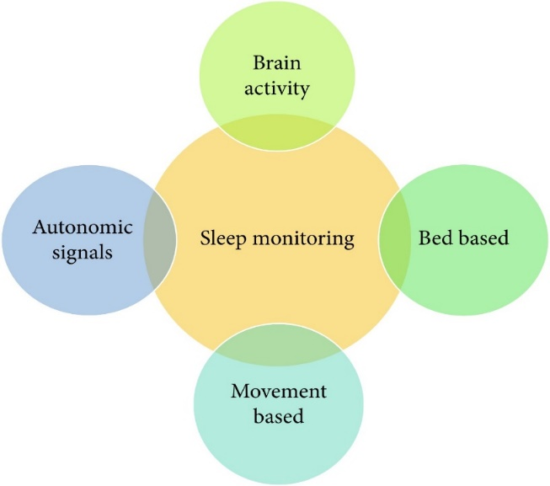

Modern sleep monitoring tools practice diverse sensing technologies. These sensors can also be used for sleep staging. We do not cover sleep stages in the proposed system. PSG (polysomnography) is a type of sleep observing technology, which measures physiological factors such as breathing, temperature, muscle fluctuation, and oxygen saturation (SPO2). With the help of this technology, researchers can classify sleep-onset and wake-up time. A device has been attached to the wrist of the patient during his sleep to analyze the physical parameters or changes. It is investigated that there is a solid relationship between wrist movement and the sleep status of the user. In another method, there is the use of audio-video recording together with a Passive Infrared (PIR) sensor to detect the patient’s sleep status.

The current study shows an ambient sleep observation method using sensors that are installed in homes. This study comprises of PIR sensors for motion detection, interaction sensors, which are connected to windows and doors, environment temperature monitors to measure the temperature of a room, and some other devices, which can detect heat and energy

## Existing Work

Several devices are also available which are currently used for sleep evaluation at home as shown in Table. Many of these are accessible in the market for purchase. The following table shows the comparison between various sleep monitoring devices where REM (rapid eye movement) and NREM (nonrapid eye movement) are sleep stages.

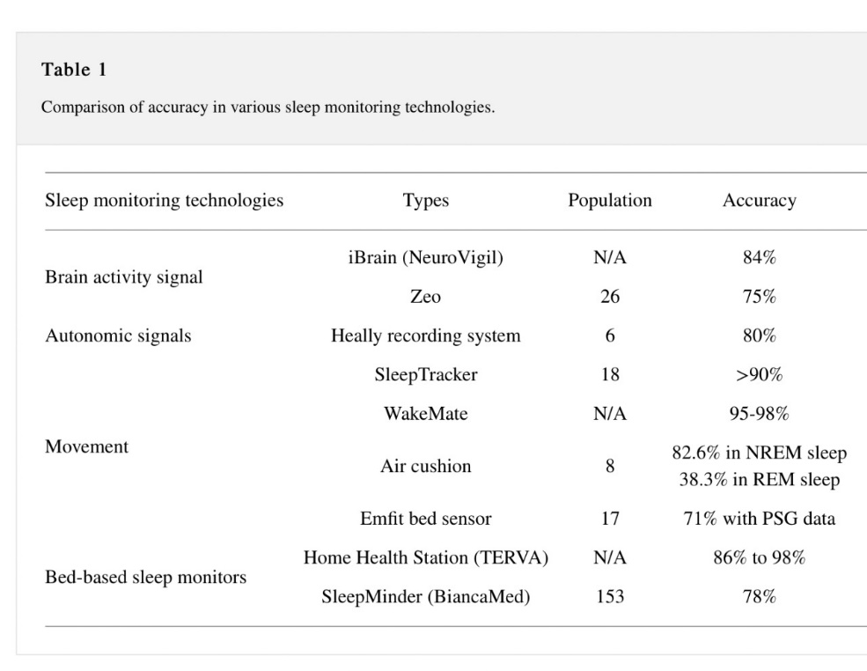

The iBrain encompasses the headband, which registers solo front lead EEG signals. Zeo is another device that comprises the headband of plastic and cloth material placed on the forehead, which measures electroencephalogram (EEG), electromyography muscle electromyogram (EMG), and electrooculogram (EOG) signals, where these signals are transferred to mobile phone through Wi-Fi or bluetooth. The Heally system encloses embedded sensors within a shirt, which is used to calculate the respiratory and cardiac movement of the patient. The SleepTracker is another device fixed on a watch. This wristwatch captures human activity during sleep. WakeMate consists of a band, which is worn on the wrist of the patient. This band sends actigraphy information to a mobile phone. This information consists of total sleep duration, how many times the patient is awake during sleep, and a “sleep quality” information based on physical activity. Air cushion consists of an air-filled beanbag, which can calculate several ambient and physical parameters. Emfit Bed Sensor consists of Emfit foil electrodes, which locates under a mattress to calculate parameters like respiration, heart rate, and body movement.

Nowadays, mobile devices are commonly used in everyday routine, which also provides several apps to monitor the sleep of patients. A system called ubiquitous architecture uses heart rate signals, sound signals, and accelerometer data for sleep monitoring. This idea works combining with the monitoring system through a smartwatch or smartphone. It also suggests an innovative and intelligent algorithm for the signal organization.

Even though, the abovementioned methods and tools have their benefits for analyzing patient’s sleep. There are many drawbacks as well. Most of them are not grounded on the IoT and machine learning. The IoT model consists of many sensing devices, data transfer protocols, and cloud computing tools, which is trending and emerging nowadays. Data processing is performed on devices like mobile devices, which requires a lot of energy that is why such models can only be feasible for a little time.

## Problems in Existing system

The existing systems are more focused on providing the assistance to the user in monitoring the sleep and guiding the user to get relaxed while sleeping using various attachments. The inventions are not focused monitors the real time health related parameters of the user while they take nap and does not provide the user with favorable ambient conditions and no means to determine their real time location at the time of nap.

In order to overcome the aforementioned drawbacks, here the proposed device will allow the user to take a nap from busy schedules and prevent the user from getting stressed and monitors the real time health related parameters of the user while they take nap along with locating the user while they are having the nap. It will also recommend the time to take nap based on the busy schedule of a person. It will monitor the sleeping activity and duration of a person and help them to provide information about their sleep activity and will also advise them how they can improve it.

## Market Survey

The survey was created to analyze the sleeping pattern of the people as we aware about sleeping disorder are seen in people. we want to know what solutions people use traditionally to overcome sleeping disorder and how our device may help people to overcome the problem. Analyzing the patient’s responses can enable us to provide service to reduce the sleepiness of the patients and hence, suggest corrective actions that can lead to better quality sleep.

Survey was created online through goggle forms. We created goggle forms to collect all the information about sleeping disorder or insomnia patients’ problem by questioning them what’s the reason of their insomnia, whether they want any sleeping assessment or not, and if they want What features they expect in the sleep tracking device.

In our survey persons from every age group participated but our main target audience was persons of age group between 18 to 30 years because sleeping problem is mostly seen in this age group person.

**Survey Questions**

1. Do you know about Insomnia?
2. Have you ever felt sleeplessness?
3. If yes than what measures did you take to overcome it?
4. Do you wish a device that will track your sleeping activities and provide you a proper routine for healthy sleep?
5. What valuable feature will you suggest to be added in that sleep monitoring device?

**Responses**

1. **Do you know about Insomnia?**

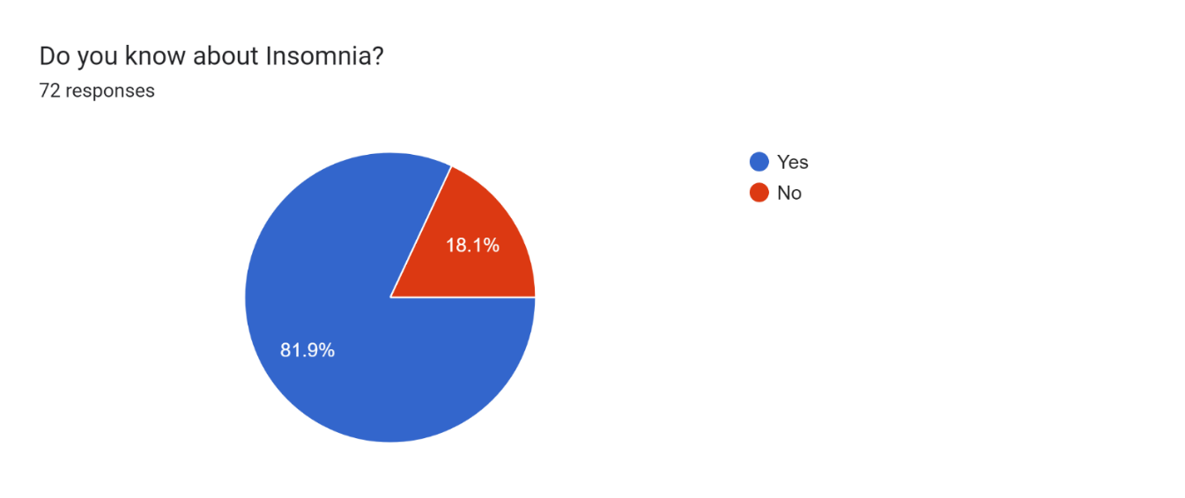

About 82% people from the survey are aware of insomnia as most of them are suffering from this problem. According to the survey insomnia is increasing rapidly and it is seen in adult mostly insomnia is happen due to pressure, overthinking about something And in today’s generation youngster are having so much pressure that’s the reason of their insomnia

1. **Have you ever felt sleeplessness?**

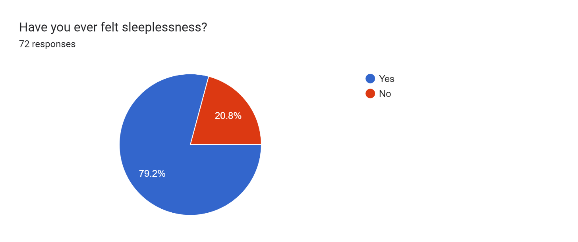

More than 79% of the people are suffering from sleeping disorder. The review of the people indicates that they want proper sleep but due to insomnia, or sleeping disorder they are unable to have proper sleep. As we all know our body requires proper sleep of 7-8 hours in adult.

1. **If yes than what measures did you take to overcome it?**

According to our survey review the people who are suffering from sleeping disorder disease some of them used to listen music to make their mind peace and have proper sleep, some of them take medicines to overcome with this problem, some of them watch movies or series, and some of them do meditation for the peace of mind to sleep properly. So to overcome with this problem they demands for sleeping assistive device that is system which will detects their sleeping routine for their proper sleep also we will add some new features in it as per their demands.

1. **Do you wish a device that will track your sleeping activities and provide you a proper routine for healthy sleep?**

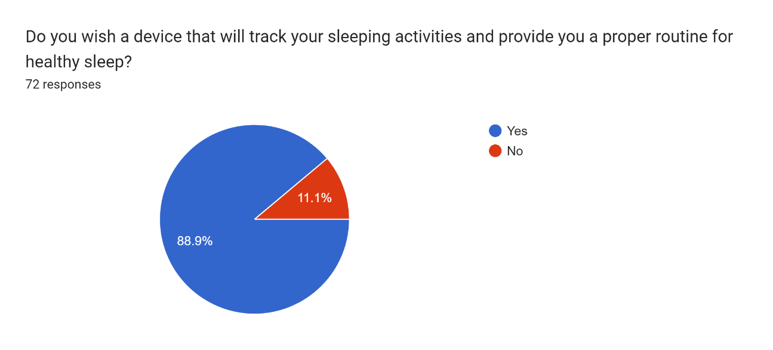

According to our survey majority of people wants to overcome with insomnia so as per their response 89% of them want sleeping device which makes them feel sleepy during night we got so many positive response for our sleeping assistive device.

1. **What valuable feature will you suggest to be added in that sleep monitoring device?**

According to the response of the people they want peaceful tune in the device which makes their mind mediate and silence. Some people want the device must detect the interrupted sleep. some wants alarm clock systems that helps them to wake up at time.

**Conclusion of survey**

So based on the survey we concluded that the problem of sleeping disorder is mostly seen in the young age group. For overcoming this problem, they are using the traditional methods like listening music, reading books, watching movies, meditation, etc. Some person even take medicine for curing their sleeping disorder even after knowing that that medicine is harmful in long-term uses. This sleeping disorder can be cured just by following a simple sleep routine. So our device will track the sleep pattern and will provide a sleep routine on weekly basis. This product can be very usefull for the persons of young age group if it meets their expectation. And for that we will include some of suggested features too. The features like deep sleep tracking, uninterrupted sleep tracking and regular alarm system inside the mobile app can be included in the device. The survey from the people indicates the high demands of most valued sleep apps as it identifies problems and gaps between their sleeping routine most the people are suffering from insomnia ,depression, and many others sleeping disorder which hampers their sleeping routine to overcome with these problems the user assistive sleeping system is very useful for the people as per their demands some people demands that they want peaceful tune in order to make their mind peaceful during sleep time, some people demands for the detection of interrupted sleep, some demands for daily routine alarm for sleep .so according to their demand we decided to make this device in such away that it will be portable to use for the users.

## Proposed System

For overcoming all the limitations of existing system, we are going to propose a personalize sleep analysis algorithm that will not only monitor the sleep activities. But it will also provide feedback, measures and diet suggestion for effective sleep.

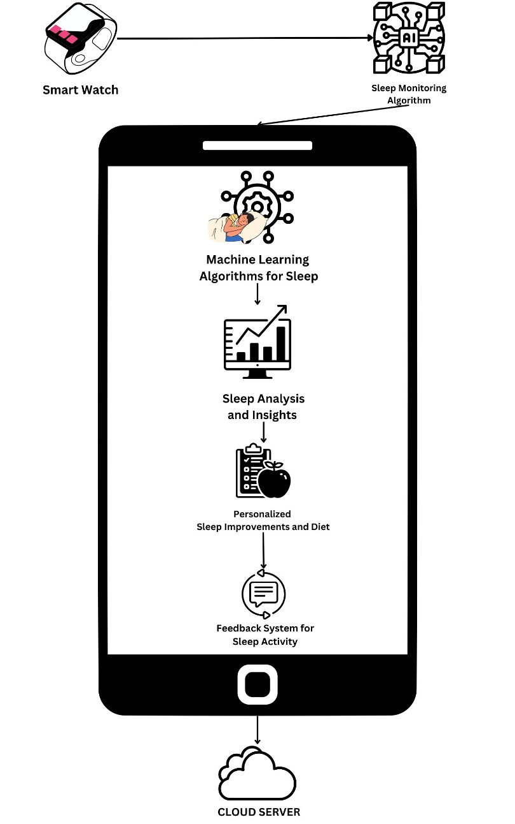

The components in the block diagram are discussed below:

* Smartwatch: This component is responsible for collecting data about the user's sleep, such as sleep duration, sleep quality, and REM sleep. The sensor will be embedded in the smartwatch and will collect data throughout the night.
* Sleep Monitoring Algorithm: This component will collect and process the data collected by the smartwatch sensor, generate a sleep score, and initiate the machine learning algorithms for sleep analysis.
* Machine Learning Algorithms: This component will analyze the sleep score generated by the sleep monitoring algorithm and provide insights and recommendations for sleep improvement.
* Sleep Analysis and Insights: This component will analyze the data collected by the smartwatch sensor and provide insights into the user's sleep patterns, such as when they are most likely to wake up, how often they wake up during the night, and how much deep and REM sleep they are getting.
* Personalized Sleep Improvements and Diet: This component will provide personalized recommendations for improving the user's sleep, as well as recommendations for their diet based on their sleep data. This component will take into account the user's sleep patterns, sleep score, and diet preferences to provide tailored recommendations.
* Feedback System for Sleep Activity: This component will provide feedback on the user's sleep activity, such as whether they are meeting their sleep goals, and suggestions for how they can improve their sleep habits. This component will also provide feedback on their diet, such as whether they are eating a balanced diet that supports good sleep.
* Sleep Data Storage: This component will store the user's sleep data in a secure and reliable database for future analysis and reference.

# CHAPTER 3

## SYSTEM DESIGN

## System Architecture

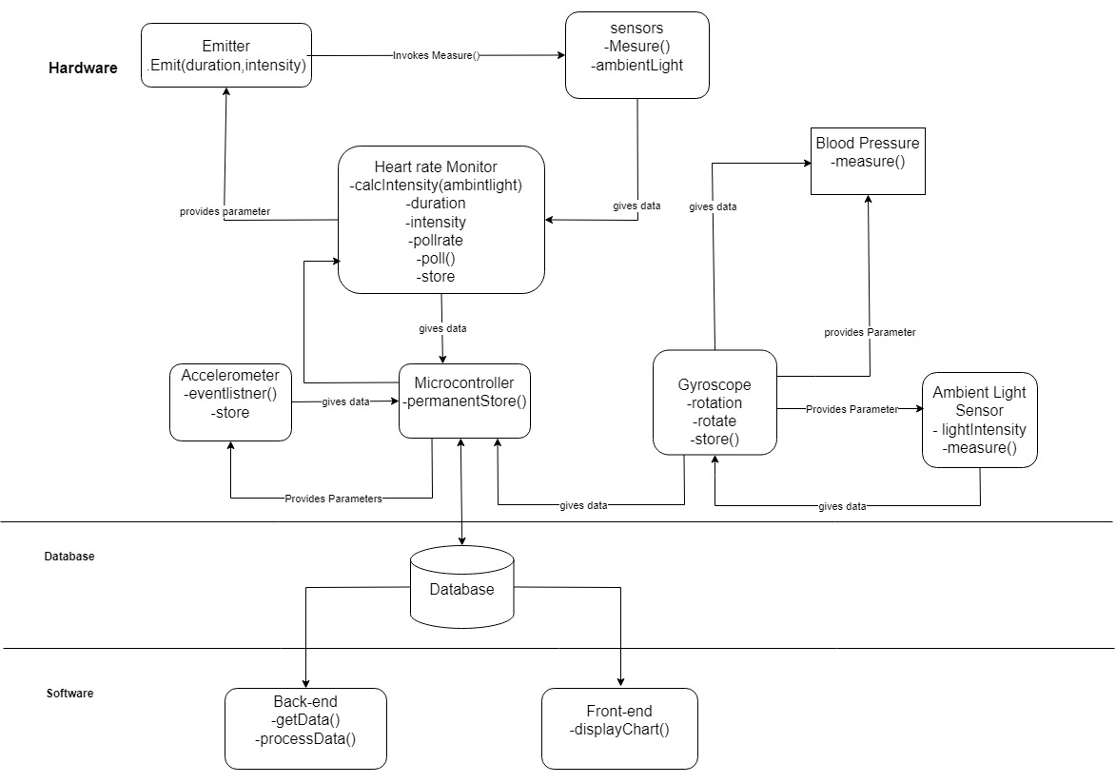

Set of programs plus data plus documentation along with mechanisms, methods and procedures. A system is a set of components that combine together to achieve common goal. It can be comprised of hardware and software. This system design is divided into hardware, database, and software.

**Hardware**

1. **Microcontroller**

Microcontroller is used for collecting and processing data from the various sensors used to track sleep. It receives data from all the other hardware components, processes them and instructs the other component. It is also responsible for sending data to the database.

1. **Optical Heart rate monitor**

It is responsible for measuring the heart rate and storing it. It is divided into two components and they are

* Emitter
* Sensor

The emitter is responsible for producing light so that the sensor can take the reading. The sensor is responsible for measuring the heart rate as well as the available ambient light. The ambient light data is sent to the Arduino Uno to calculate the required duration and intensity of light so that the sensor can take the reading.

1. **Accelerometer**

It is responsible for detecting any movement of the user during sleep. The measured movement is then sent to the Arduino Uno. The sensitivity is adjusted by the Arduino Uno.

1. **Gyroscope**

Gyroscope can detect movements such as turning over or changing positions, as well as more subtle changes in orientation caused by breathing and heart rate. By analyzing these movements and changes over time, the smartwatch can provide data on the wearer's sleep duration, sleep stages, and quality of sleep.

1. **Ambient Light Sensor**

Ambient light sensors can also be used in sleep monitoring by detecting changes in the lighting conditions in a room. By measuring the amount of light in the environment, a sleep tracker or smartwatch can determine when the wearer has gone to bed and when they wake up.

**Database:**

Microcontroller makes HTTP Request to Web Server.

* Web Server runs PHP script.
* PHP script gets data from HTTP Request, processes the data, and then interacts with MySQL database.
* PHP script processes the result and returns the result to Arduino via HTTP response.

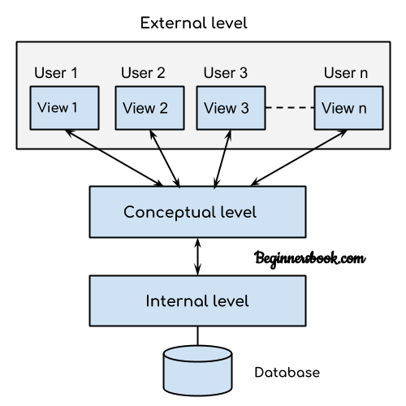

According to the requirement, the data can be presented on external level can be used to monitor your sleeping pattern and give you brief information about your daily sleep.

The following are the layers in the software architecture of a sleep monitoring system:

* Data Collection Layer: This layer is responsible for collecting data from the sensors, such as heart rate, breathing rate, body temperature, and movement. The data can be stored locally on the device or transmitted to a cloud-based storage system for further analysis.
* Data Processing Layer: This layer processes the data collected by the data collection layer to identify patterns and anomalies in the sleep behavior of the user. The data may be pre-processed, filtered, and normalized before being analyzed.
* Analytics Layer: This layer performs more complex analysis of the data, such as identifying sleep stages (light, deep, REM), calculating sleep efficiency, and detecting sleep disorders such as sleep apnea.
* User Interface Layer: This layer presents the analyzed data to the user in an easy-to-understand format, such as a mobile app or a web-based dashboard. The user can view their sleep data, set sleep goals, and track their progress over time.
* Integration Layer: This layer integrates the sleep monitoring system with other applications and devices, such as fitness trackers, smart home devices, and electronic health records.

**Software:**

In software it uses a mobile application that contain a machine learning algorithm that can suggest measures to improve sleep.

The first step would be to gather data on the user's sleep patterns, which can be collected using a smartwatch or other wearable device that is capable of tracking sleep. This data can include metrics such as total sleep time, time spent in each sleep stage, sleep interruptions, and heart rate variability.

Once the data is collected, it can be used to train a machine learning model that can analyze the patterns and provide suggestions for improving sleep. The model could use a variety of techniques, such as regression analysis, decision trees, or neural networks, to identify correlations between the data and specific factors that may be affecting sleep quality.

Based on these correlations, the model could then suggest measures that the user can take to improve their sleep. For example, if the model identifies a correlation between poor sleep quality and high caffeine consumption, it could suggest that the user reduce their caffeine intake before bedtime. Similarly, if the model detects that the user is consistently waking up during the night, it could suggest that they establish a regular bedtime routine or practice relaxation techniques before going to sleep.

## Use Case Diagram

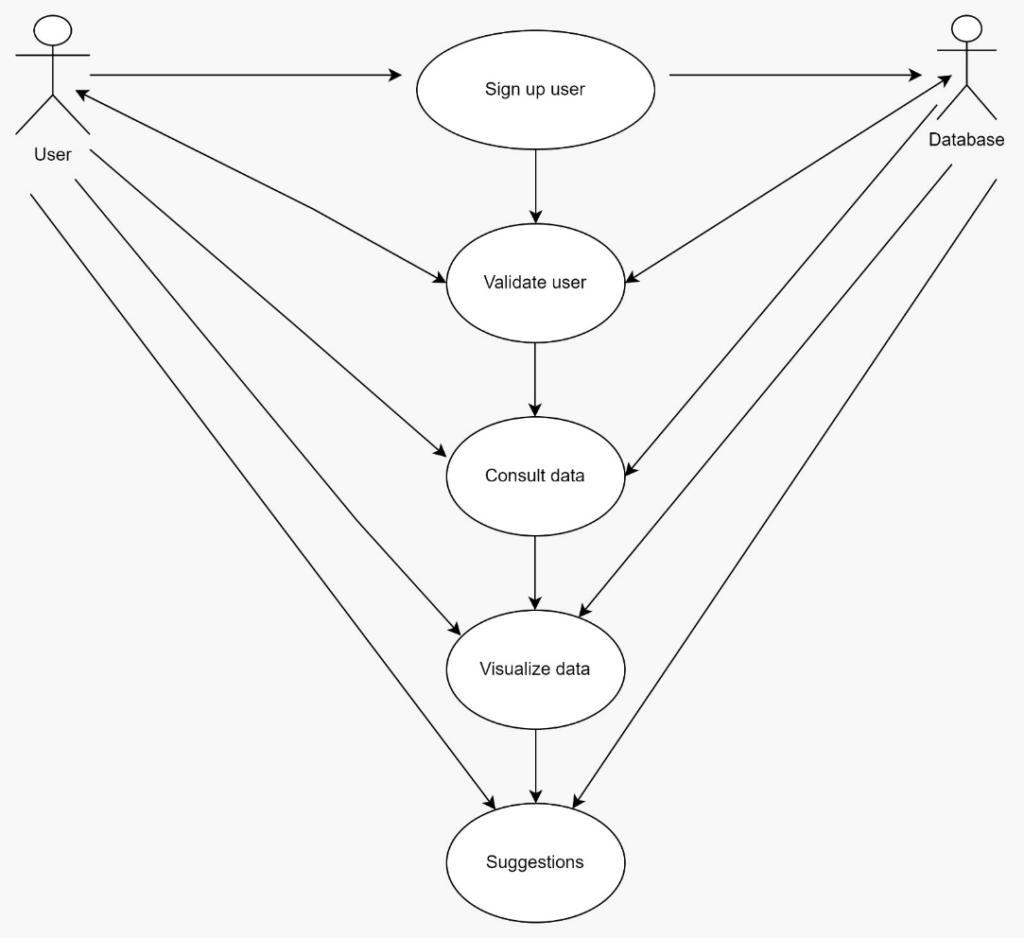

The use case diagrams show the representation of the interaction between the users and the system. It shows the complete use case diagram. The user needs first to sign up, just once, and then validate the user and password to be able to consult the chosen appliance and visualize the data on the system and whatever the result is the system will provide the user with the suggestions. First the user will sign up which will be recorded in the database then the user needs to enter their password after signing up. This is the first stage process where they are new to the device. After entering the password, the data will be consult among the user and the database then the main result i.e., visualization of the data which has been recorded in the database that will be displayed and accordingly to that the user will get the suggestions from the system and will improve their sleep cycle. Therefore, main effects and the progress can only be seen after the visualization of data.

## Class Diagram

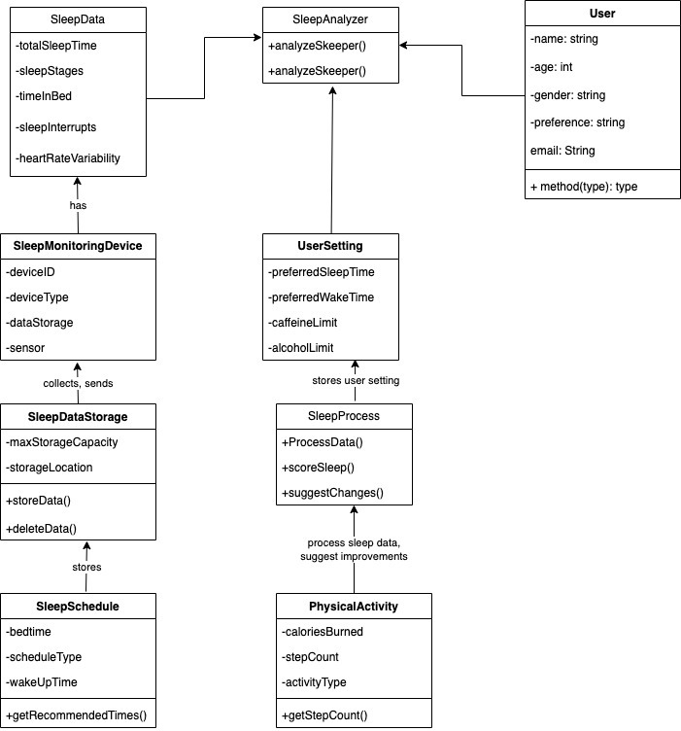

In this diagram, the User class has attributes such as name, age, gender, email, and password, which are used to authenticate the user and personalize sleep improvement suggestions. The Sleep Monitoring Device and SleepProcessor classes are the same as in the previous diagram, but with additional methods to manage sleep data and perform sleep analysis. The UserAction class represents the user's response to sleep improvement suggestions, with a method to take action on a suggested improvement.

* User: User class stores the basic information of the user like name, email, age, gender, etc.
* SleepData: stores sleep data, such as total sleep time, time in bed, sleep stages, sleep interruptions, and heart rate variability.
* SleepAnalyzer: analyzes sleep data to provide insights and recommendations, with a method analyzeSleep().
* SleepMonitoringDevice: collects and sends sleep data, with attributes device ID, device type, data storage, and sensor.
* UserSettings: stores user settings, such as preferred sleep and wake times, caffeine and alcohol limits, with attributes preferred sleep time, preferred wake time, caffeine limit, and alcohol limit.
* SleepDataStorage: stores sleep data, with attributes storage location and maximum storage capacity, and methods storeData() and deleteData().
* SleepProcessor: processes sleep data to generate a sleep score and suggest changes, with methods processData(), scoreSleep(), and suggestChanges().
* SleepSchedule: stores a user's sleep schedule, with attributes bedtime, wake-up time, and schedule type, and method getRecommendedTimes() to suggest a bedtime and wake-up time based on the schedule type.
* PhysicalActivity: stores physical activity data, such as step count, calories burned, and activity type, and method getStepCount() to get the user's step count.

## Activity Diagram

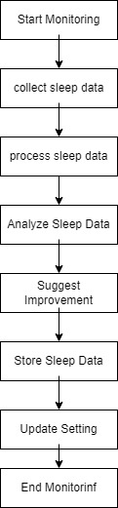

* Start Monitoring: The system starts monitoring sleep data.
* Collect Sleep Data: The system collects sleep data from the sleep monitoring device.
* Process Sleep Data: The system processes the collected sleep data to generate a sleep score.
* Analyze Sleep Data: The system analyzes the sleep score to provide insights and recommendations for improvement.
* Suggest Improvements: The system suggests changes to the user's sleep schedule, physical activity, and other habits to improve sleep.
* Store Sleep Data: The system stores the sleep data in the sleep data savtorage.
* Update Settings: The system updates the user's settings based on the suggested improvements.
* End Monitoring: The system ends the sleep monitoring session.

## Sequence Diagram

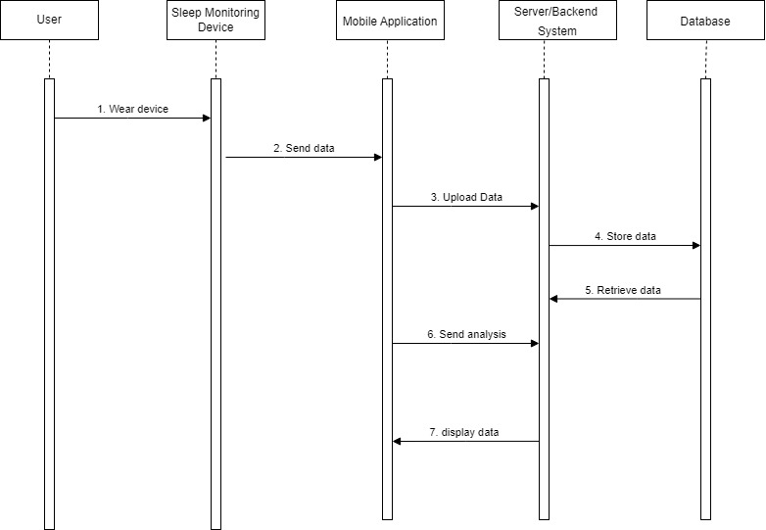

In this sequence diagram, there are five actors. User, sleep monitoring Device, Mobile Application, Server/Backend System and Database. The sequences of message are as follows:-

1. User-Relationship: By donning the sleep monitor, the user starts the conversation.
2. Transmission of Device to Application Data: Data is sent to the mobile application from the sleep monitoring gadget.
3. Upload Application to Server Data: The received data is uploaded to the server/backend system by the mobile application.
4. Data Storage on Servers: For further examination, the server keeps the data in the database.
5. Data Retrieval Option: The system can access stored data from the database if needed.
6. Analysis of Servers and Creation of Reports: The mobile application receives the analysis that the server produces after it has examined the data and produced insights.
7. Display of Application Data to User: The user can view the analysis findings through the mobile application.

From the user's initial activity to the presentation of analyzed data on the user's device, this sequence explains the information flow within the system. The main interactions between the user, mobile application, server/backend system, sleep monitoring device, and database are highlighted.

# CHAPTER 4

## TOOLS DESCRIPTION

## Hardware Requirements: Description

The hardware requirements for users of sleep monitoring system are as follows –

* 1 GB of RAM
* 1.6 GHz or faster processor
* Hard disk space: 5 GB or above
* Android device for running the application.
* Network adapters for connection to the Internet
* Graphics display resolution
* Smartwatch for data collection

## Software Requirements: Description

The software requirements for sleep monitoring system are divided into subsections as follows:

* + 1. **O**perating System Requirements
* OS X El Capitan (10.11+)
* Windows 7, 8.0, 8.1, and 10 (32-bit and 64-bit)
  + 1. **Client-side Software Requirements**
* Google Chrome
* Android Studio
* Git Bash
  + 1. **Developer libraries**
* Android
* Android-SDK
* Firebase

These requirements satisfy the Developers and Users to access sleep monitoring system for seamless user experience.

# CHAPTER 5

## IMPLEMENTATION

## Description

For easy and quick development of the project, we have divided the project into 5 modules.

**Module 1: Data Set Collection**

For the dataset, we used Kaggle. From Kaggle, we retrieved dataset of Fitabase smartwatch [25]. The retrieved dataset was used as training and testing dataset for creating model.

**Module 2: Data Integration and Preprocessing**

Merge different datasets into a comprehensive dataset and perform data cleaning and preparation tasks like handling missing values, normalizing data, and feature engineering.

**Module 3: Exploratory Data Analysis (EDA)**

Conduct an initial investigation on the data to discover patterns, spot anomalies, test hypothesis, and check assumptions with the help of statistical summaries and graphical representations.

**Module 4: Model Building**

Develop and train machine learning models using the processed data to predict or classify the target variable, such as sleep quality or duration.

**Module 5: Model Evaluation**

Assess the performance of the machine learning model using appropriate metrics like mean squared error, R-squared for regression, or accuracy and F1-score for classification.

**Module 6: Deployment**

Implement the trained model into a real-world application or system, ensuring it can process new data and provide predictions or insights as intended.

## Code Snippets of Sleep Monitoring System

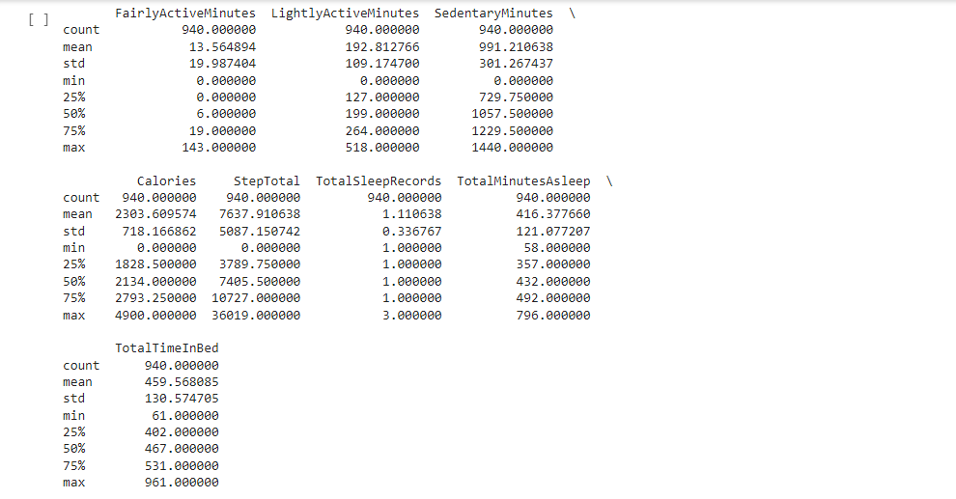

# CHAPTER 6

### CONCLUSION

In conclusion, a sleep monitoring system that uses a smartwatch and machine learning algorithms can provide users with valuable insights into their sleep patterns and recommendations for improving their sleep quality. By collecting data on sleep duration, sleep quality, and other sleep-related metrics, the system can provide personalized insights into sleep patterns, such as when the user is most likely to wake up and how often they wake up during the night. Machine learning algorithms can then analyze this data and provide tailored recommendations for improving sleep, such as adjusting sleep schedules or changing sleeping positions. Additionally, by including a feedback system that provides suggestions on sleep activity and diet, the system can provide users with a comprehensive set of recommendations for improving their overall health and well-being. A sleep monitoring system that uses a smartwatch and machine learning algorithms has the potential to be a powerful tool for individuals looking to improve their sleep quality and overall health. With the right design and implementation, such a system can provide users with valuable insights and personalized recommendations, ultimately leading to better sleep and a better quality of life.

# REFERENCES

1. Ibáñez V, Silva J, Cauli O. A survey on sleep assessment methods. PeerJ. 2018 May 25;6:e4849. doi: 10.7717/peerj.4849. PMID: 29844990; PMCID: PMC5971842.
2. Biajar, Anmol, Tatyana Mollayeva, Sandra Sokoloff, and Angela Colantonio. “Assistive Technology to Enable Sleep Function in Patients with Acquired Brain Injury: Issues and Opportunities.” British Journal of Occupational Therapy 80, no. 4 (April 2017): 225–49. <https://doi.org/10.1177/0308022616688017>.
3. Metsis, V., Kosmopoulos, D., Athitsos, V. et al. Non-invasive analysis of sleep patterns via multimodal sensor input. Pers Ubiquit Comput 18, 19–26 (2014). <https://doi.org/10.1007/s00779-012-0623-1>
4. Lee XK, Chee NIYN, Ong JL, Teo TB, van Rijn E, Lo JC, Chee MWL. Validation of a Consumer Sleep Wearable Device With Actigraphy and Polysomnography in Adolescents Across Sleep Opportunity Manipulations. J Clin Sleep Med. 2019 Sep 15;15(9):1337-1346. doi: 10.5664/jcsm.7932. PMID: 31538605; PMCID: PMC6760396.
5. [Ronald Stuart BENSON](https://patents.google.com/?inventor=Ronald+Stuart+BENSON), [Ryan Cameron DENOMME](https://patents.google.com/?inventor=Ryan+Cameron+DENOMME). Sleep monitoring system (2018) U.S. Pat. No.10874350B2
6. [Todd Youngblood](https://patents.google.com/?inventor=Todd+Youngblood), [Tara Youngblood](https://patents.google.com/?inventor=Tara+Youngblood) Stress reduction and sleep promotion system (2021) U.S. Pat No.11013883B2
7. [Kody Lee Karschnik](https://patents.google.com/?inventor=Kody+Lee+Karschnik), [Omid Sayadi](https://patents.google.com/patent/US20210289947A1/en?oq=US20210289947A1), [Wade Daniel Palashewski](https://patents.google.com/?inventor=Wade+Daniel+Palashewski), [Ramazan Demirli](https://patents.google.com/patent/US20210289947A1/en?oq=US20210289947A1), [Eric Rose](https://patents.google.com/patent/US20210289947A1/en?oq=US20210289947A1), [Saurabh Chhaparwal](https://patents.google.com/?inventor=Saurabh+Chhaparwal) Bed with foot warming system (2020) U.S. Pat No. 20210289947A1.
8. PAN, Qiang & Brulin, Damien & Campo, Eric. (2020). Sleep monitoring systems: Current status and future challenges (Preprint). JMIR Biomedical Engineering. 5. 10.2196/20921.
9. T. -Y. Han, S. -D. Min and Y. Nam, "A Real-Time Sleep Monitoring System with a Smartphone," 2015 9th International Conference on Innovative Mobile and Internet Services in Ubiquitous Computing, Santa Catarina, Brazil, 2015, pp. 458-461, doi: 10.1109/IMIS.2015.69.
10. N. Surantha, G. P. Kusuma and S. M. Isa, "Internet of things for sleep quality monitoring system: A survey," 2016 11th International Conference on Knowledge, Information and Creativity Support Systems (KICSS), Yogyakarta, Indonesia, 2016, pp. 1-6, doi: 10.1109/KICSS.2016.7951426.
11. Suzuki, Takuji & Ouchi, Kazushige & Kameyama, Ken-Ichi & Takahashi, Masaya. (2009). Development of a Sleep Monitoring System with Wearable Vital Sensor for Home Use.. 326-331.
12. *Nonconstrained Sleep Monitoring System and Algorithms Using Air-Mattress With Balancing Tube Method*. (2010, January 1). IEEE Journals & Magazine | IEEE Xplore. <https://ieeexplore.ieee.org/stamp/stamp.jsp?tp=&arnumber=5290162&tag=1>
13. Development and Preliminary Validation of Heart Rate and Breathing Rate Detection Using a Passive, Ballistocardiography-Based Sleep Monitoring System David C. Mack, James T. Patrie, Paul M. Suratt, Robin A. Felder, and Majd Alwan, Senior Member, IEEE <https://ieeexplore.ieee.org/stamp/stamp.jsp?tp=&arnumber=4663856>
14. Promises and Challenges in the Use of Consumer-Grade Devices for Sleep Monitoring Sirinthip Roomkham , David Lovell , Joseph Cheung , and Dimitri Perrin. <https://ieeexplore.ieee.org/stamp/stamp.jsp?tp=&arnumber=8309286>
15. Long-term Sleep Monitoring System and Long-term Sleep Parameters using Unconstrained Method Jaehyuk Shin, Youngjoon Chee, and Kwangsuk Park, Member, IEEE <https://citeseerx.ist.psu.edu/document?repid=rep1&type=pdf&doi=7bb91d3bbf05f30ba1dcaa7d4ebf9ffb0c7042f9>
16. de Zambotti M, Baker FC, Colrain IM. Validation of Sleep-Tracking Technology Compared with Polysomnography in Adolescents. Sleep. 2015 Sep 1;38(9):1461-8. doi: 10.5665/sleep.4990. PMID: 26158896; PMCID: PMC4531414.
17. Zilu Liang and Bernd Ploderer. 2016. Sleep tracking in the real world: a qualitative study into barriers for improving sleep. In Proceedings of the 28th Australian Conference on Computer-Human Interaction (OzCHI '16). Association for Computing Machinery, New York, NY, USA, 537–541. <https://doi.org/10.1145/3010915.3010988>
18. Driller, M. W., Dunican, I. C., Omond, S. E. T., Boukhris, O., Stevenson, S., Lambing, K., & Bender, A. (2023). Pyjamas, Polysomnography and Professional Athletes: The Role of Sleep Tracking Technology in Sport. *Sports*, *11*(1), 14. <https://doi.org/10.3390/sports11010014>
19. Kuosmanen, E., Visuri, A., Kheirinejad, S., Van Berkel, N., Koskimäki, H., Ferreira, D., & Hosio, S. (2022). How Does Sleep Tracking Influence Your Life? *Proceedings of the ACM on Human-computer Interaction*, *6*(MHCI), 1–19. <https://doi.org/10.1145/3546720>
20. Y. Wei et al., "The Design and Realization of Sleep-monitoring System Based on Body-movement Signals," 2019 2nd International Conference on Safety Produce Informatization (IICSPI), Chongqing, China, 2019, pp. 533-536, doi: 10.1109/IICSPI48186.2019.9096055.
21. N. Surantha, O. K. Utomo and S. M. Isa, "High-Performance and Resource-Efficient IoT-based Sleep Monitoring System," 2020 IEEE 91st Vehicular Technology Conference (VTC2020-Spring), Antwerp, Belgium, 2020, pp. 1-5, doi: 10.1109/VTC2020-Spring48590.2020.9129521.
22. P. Barsocchi, M. Bianchini, A. Crivello, D. La Rosa, F. Palumbo and F. Scarselli, "An unobtrusive sleep monitoring system for the human sleep behaviour understanding," 2016 7th IEEE International Conference on Cognitive Infocommunications (CogInfoCom), Wroclaw, Poland, 2016, pp. 000091-000096, doi: 10.1109/CogInfoCom.2016.7804531.
23. S. T. -B. Hamida and B. Ahmed, "A remote deep sleep monitoring system based on a single channel for in-home insomnia diagnosis," 2015 7th International Conference on New Technologies, Mobility and Security (NTMS), Paris, France, 2015, pp. 1-2, doi: 10.1109/NTMS.2015.7266469.
24. Survey form link : <https://forms.gle/pmdy45LKJJ6htHd19>

Resposes of the survey : <https://docs.google.com/spreadsheets/d/1U6WLk7Ne0LV79moamtNjVPHlrR2nn_6hfSQIf1csSro/edit?usp=sharing>

1. Kaggle Dataset Link: <https://www.kaggle.com/code/nevillejeffree/fitabase-data-analysis/input>